Character Suitcase
Due: Tuesday, November 20th

Description of Project:

This project will help you to think about and develop the main character for your fictional narrative. The final product will be a “packed suitcase” that your character would take with him/her on a trip. It will need to include items that describe the character’s traits. The objects may be handmade, computer art, stickers, or small objects. You will also need to write a brief description stating why the character would choose each item.

Materials:

- Red or blue box (supplied by Miss Rodgers)
- Construction paper
- Crayons, markers, or colored pencils
- Scissors
- Glue sticks
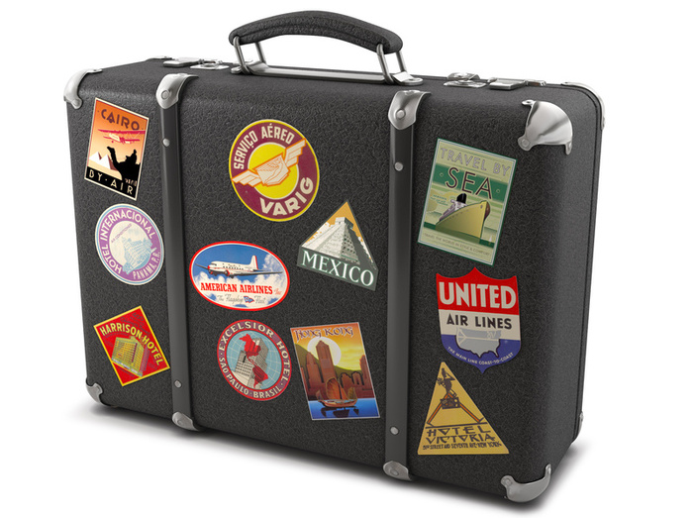
- Stickers (optional)
- Computer art (optional)

Step-By-Step Directions

1. Using construction paper, create a luggage tag that has the character’s name, address, and destination written on it.

2. Use stickers, computer art, or construction paper to create memorabilia to decorate the outside of the suitcase (box), such as bumper stickers or mementos from previous trips.

3. Decide on TEN items that your character would pack. These items may be both tangible (things you can touch…umbrella, hatchet, etc) and intangible (things you can’t touch…courage, intelligence).

4. Create the ten items using construction paper, stickers, computer art, or small objects.

5. Place the items inside the box.

6. Write a one-page (typed, font size 12, Times New Roman) story explaining why the character chose to pack each item. It should be written from the character’s point of view. You should describe at least 5 of the character’s traits.

Grading

This project will be graded with the rubric on the following page. Please use the Student Checklist column to make sure you have completed each section completely. This project will be counted as a benchmark assessment for Writing.
Name _____________________ Date __________

Character Suitcase Rubric & Student Checklist
Category | Points | Student  Checklist | Teacher’s Rubric
Outside of suitcase is decorated neatly and reveals something about the character. | 15
Luggage tag is spelled accurately and reveals something about the character. | 5
Ten items are included in the suitcase. | 10
All items are created with care. | 15
Explanation of suitcase items is typed. | 5
Explanation is written from the character’s point of view. | 5
Explanation thoroughly explains why your character chose to bring these items. | 20
Explanation describes at least 5 character traits | 5
Spelling, capitalization, and punctuation are correct. | 20
Total points | _________/100

Example:

Marc Jone’s Suitcase

I was next in line at the security station in Newark Airport. I put my suitcase on the conveyor belt and walked through the security system. “Beep, beep, beep!” the alarm rang loudly. “Please step over here,” the officer stated firmly. The officer took me to a little glass room with my suitcase. He placed my suitcase on top of a metal table and opened it up. I couldn’t believe my eyes. He was going through my stuff! The police officer instructed me to give him an explanation about each item he was about to pull out of my suitcase.
First, out popped Bugs. This grey, stuffed bunny keeps me safe. I tend to be kind of a worrywart sometimes especially when I am on a plane. Therefore, I hang onto Bugs for support. Stuffed right underneath Bugs is my first aid kit. Falling down is my specialty! I am clumsy in deed and should never go anywhere without first aid supplies. To keep me from feeling lonely or isolated on my trip I brought along a picture of my best friend. Her name is Sarah McClay. I have known her for seven years!
Then, the officer pulled out what looked like an empty plastic bag, however I could see what was in it. The bag contains trust, responsibility, and care. I have a good heart and hold true to my word. Maybe that is why Sarah and I have been friends for so long.
On the bottom of my suitcase, the officer found some of my guilty pleasures including my journal, I pod, and sword. When I go on vacation I enjoy writing about my travels in my journal. Music from my I pod helps me to stay calm and sometimes fall asleep. My sword is just for fun, especially because I like to use my imagination.
At last, the office found my lucky rabbit’s foot. I bring it with me everywhere I go because you never know when you will need good luck. I guess some people call me superstitious. “Ah ha” exclaimed the officer. The metal keychain on the lucky rabbit’s foot must have caused the alarm to go off. The office placed my belongings back into my suitcase and let me go on my merry way. I wonder what exciting experience I will stumble upon next!

Sample Luggage Tag:

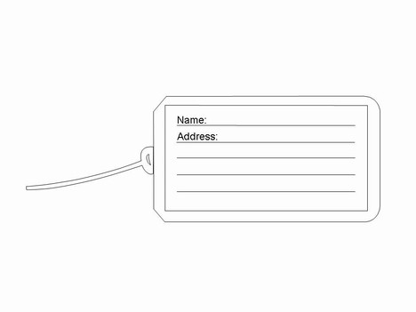
You may use this as a guide or cut out to use on your suitcase. You may want to use a piece of string to attach the tag to your suitcase or glue it to one of the top flaps.

Destination:

